Accessing the K-12 Writing Continuum

The K-12 Writing Continuum focuses on three types of writing styles, Narrative, Informative and Argumentative. To access the writing continuum for a specific grade level, follow the instructions below.

- Go to the Learning Central WCPSS Academic Dashboard. Click here to access the Learning Central dashboard.

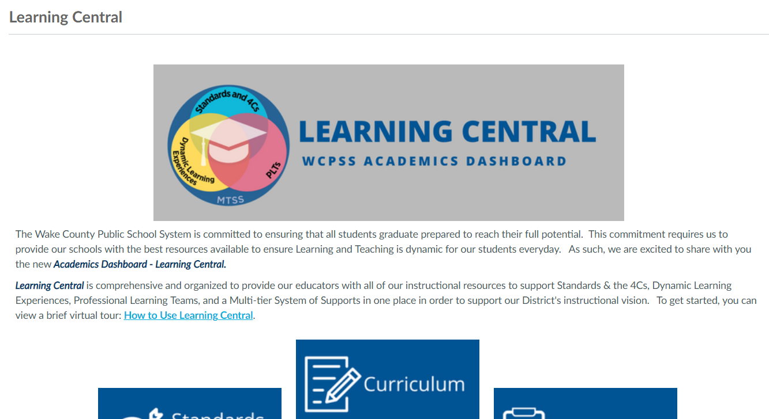

- Once on the Learning Central Dashboard, click on the blue Curriculum tab.

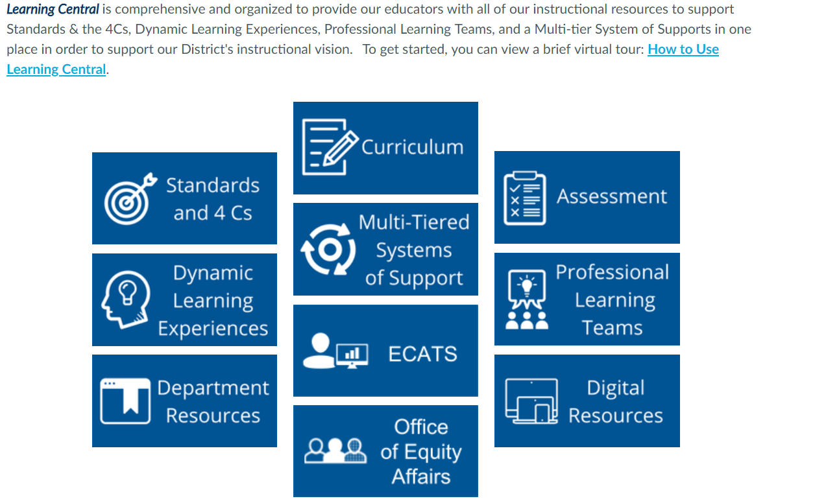

- Click on the green K-12 Writing Curriculum tab.

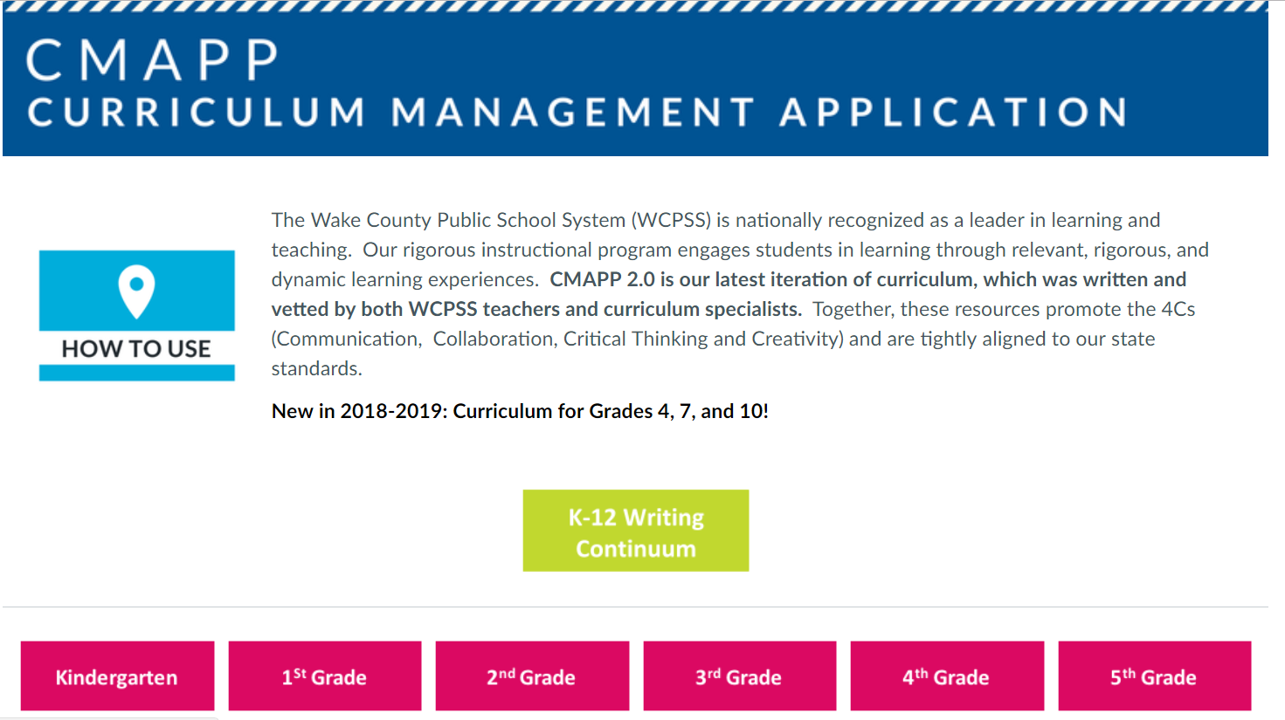

- Select a folder to accesss the writing continuum for a specific grade level.



