Accessing Rubrics in EL Education, MVP, and Open Up Curriculum

Different samples of rubrics can be found in the EL, MVP, and Open Up curriculum. To access these curriculum, follow the instructions below.

- Go to the Learning Central WCPSS Academic Dashboard. Click here to access the Learning Central dashboard.

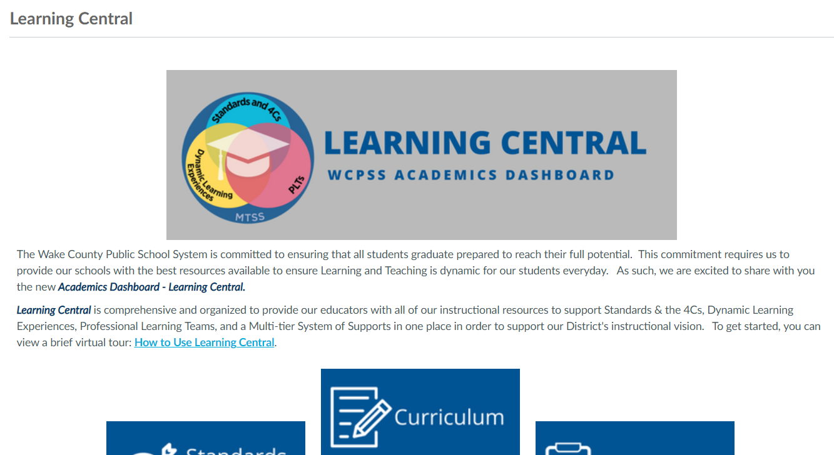

- Once on the Learning Central Dashboard, click on the blue Curriculum tab.

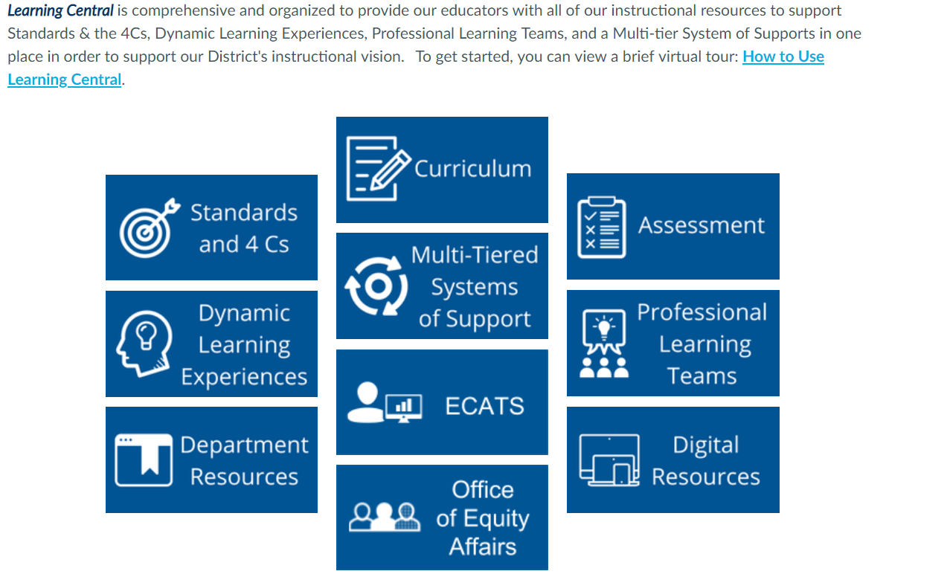

- EL Education curriculum is used in grades 3-8 English Language Arts classes, MVP curriculum is used in Math 1 and Math 2 classes, and Open Up curriculum is used in grades 6-8 Mathematics classes.

Click on a grade level for which the specified curriculums are used.
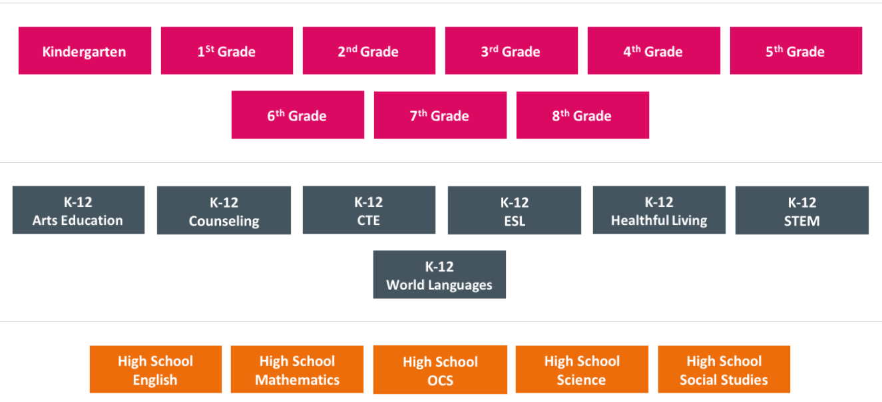

- Select the Langauge tab to access rubrics used in the EL Education curriculum or select the Mathematics tab to access rubrics used in the MVP and the Open Up curriuclum.

