Accessing Rubrics in CMAPP

The Curriculum Management Application (CMAPP) site provides samples of different types of rubrics specific to subject and grade level.

Follow the instructions below to get quick access to these rubrics.

- Click on the link https://cmapp.wcpss.net/ .

- Follow the instruction on the page to login.

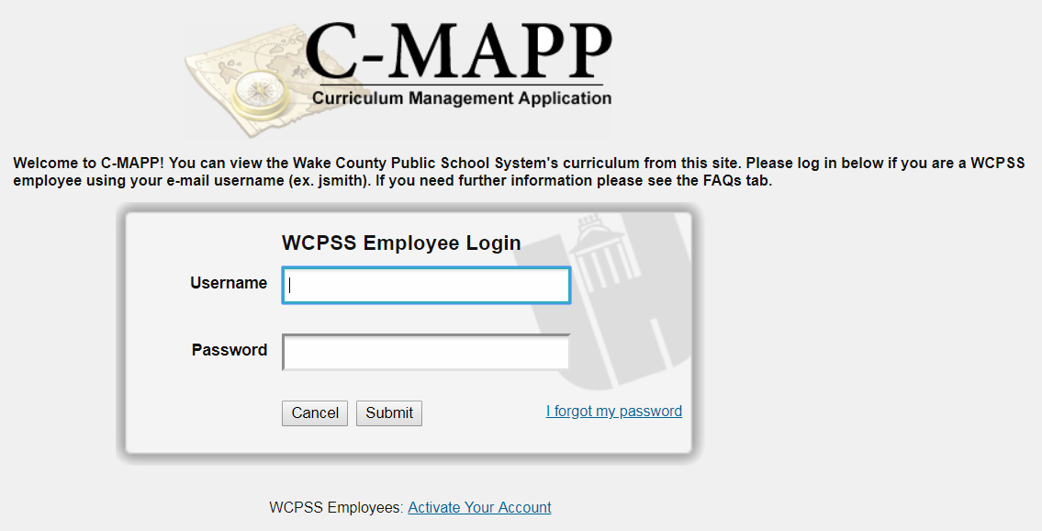

- Once logged in, click on the search tab located in the blue banner.

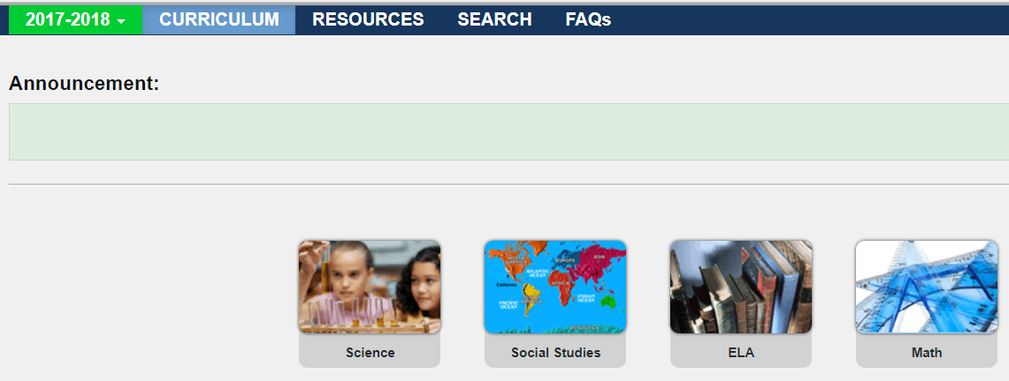

- In the search menu, click on the dropdown arrow for level and select your specific school level.

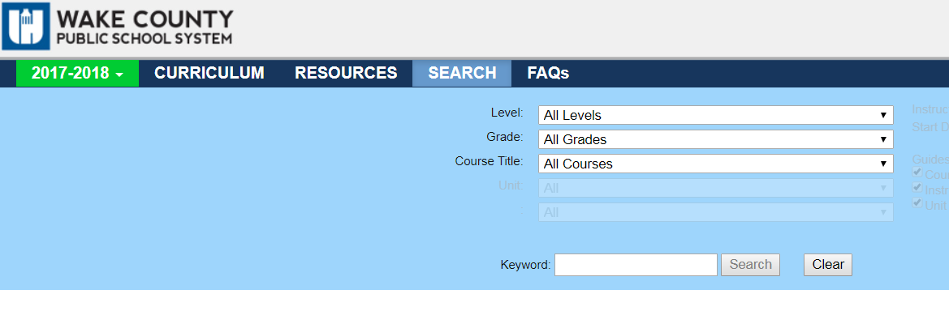
- After selecting your specific school level, type the word “rubrics” in the keyword search bar and then click search.
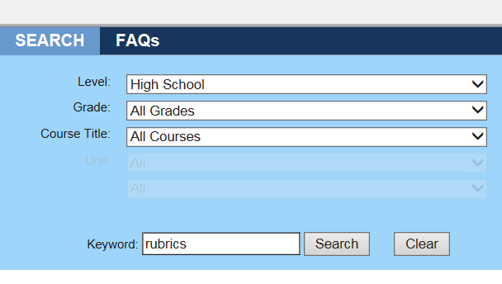

- View the different samples of rubrics available for your grade level.

